Cayuga Lake Cruising Fleet

Sailing Instructions
2019 Whitesail Regatta

- Rules. The regatta will be governed by the current rules as defined in The Racing Rules of Sailing.
- Entries. Any sailing vessel is welcome to compete in the Whitesail Regatta. To allow for day-of scoring, it is necessary to report your PHRF rating by the start of racing. There is no entry fee associated with the Whitesail Regatta.
- Notices to Competitors. Notices to competitors will be posted on the official notice board located at the IYC south pavilion.
- Signals Made Ashore. No signals will be displayed on shore. The Race Committee (or RC) may postpone the race by making an announcement at the competitors’ meeting or by VHF radio, and may start a race at any time.
- Schedule. A competitors’ meeting will be held at the IYC south pavilion at 9:30am. The first race each day is scheduled to start at 10:00am
The goal is to have at least 5 races.
No race will start after 4:30 PM.
- Courses and Marks. There will be two courses used for the Whitesail Regatta: W1 and W2 (shown below).
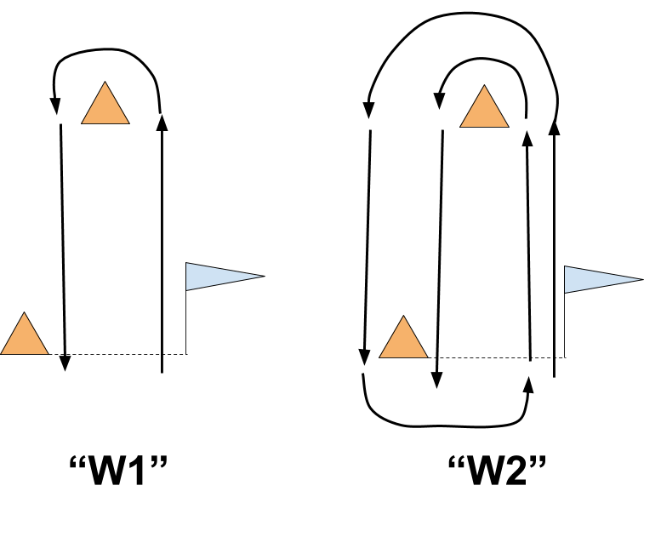
The courses will be around the fixed marks described in Appendix A, or other objects announced by the RC. The course will be announced by the race committee by VHF radio prior to the starting sequence for each race.

- Start. The start line will be between the IYC flagpole and the nearby fixed mark, or other marks announced at the competitors’ meeting or by VHF radio. The RC will provide a 5-minute starting sequence for each race via VHF radio and sound signals.
- Finishing. The finish line will be between the IYC flagpole and the nearby fixed mark, or other marks announced at the competitors’ meeting or by VHF radio.
- Shortening course and change of course. The RC may shorten the course by announcement by VHF radio at any time during a race. The RC will also display an “S” flag, and make audible signals.
The RC may set a new finish line at one of the marks of the current course, if the announcement is made before the first boat has reached that mark. In this case the finish line shall be an imaginary line extending 5 boat lengths from the mark at right angles to the course from the previous mark and leaving the finishing mark on its original required side.
The RC may add or delete marks from the course provided the announcement is made before any boat has rounded the mark prior to the added or deleted mark.
- Taking a penalty at the time of an incident. Rule 44.1 is changed so that the Two-Turns Penalty is replaced by the One-Turn Penalty.
- Communication. The RC may broadcast its announcements on VHF channel 80 (US band). Failure of a boat to hear an announcement broadcast in this manner shall not be grounds for redress or protest.
- Protests. A boat initiating a protest shall notify the RC over VHF of its intent to lodge a protest. Protests shall be delivered to the RC or its designee within one hour after the last boat finishes the final race. Hearings will be held as soon as practicable at the IYC clubhouse or south pavilion.
- Scoring. The Low Point Scoring System in Appendix A of the racing rules will be used. Rule A9 will apply.
If 6 or more races are completed, each boat’s two worst scores will be excluded from her series score. This amends The Racing Rules of Sailing.
- No Spinnaker Rule. For this regatta, no boat shall fly a spinnaker. The use of spinnaker poles or whisker poles IS allowed.
- Special Considerations. In the interest of the Fleet and in the spirit of competition, the RC may modify these rules of racing before or during a race and for any or all races that day if all of the racing boats competing in those races be in agreement.
Appendix A Course Marks
Mark | Name | Description | Approx Location
I or A | IYC: Start/Finish | Short & fat, WHITE | 42°29.790'N, 76°32.198'W
N | Near Maplewood | Tall, white cylinder | 42°30.138'N, 76°32.438'W
F | Far Maplewood | Tall, white cylinder | 42°30.819'N, 76°32.703'W
C | Crowbar | Tall, white cylinder (low in water) | 42°31.499'N, 76°33.351'W
L | Ladoga | Tall, white cylinder | 42°31.926'N, 76°32.686'W
B | Blue Building/Barge | Tall, white cylinder | 42°31.369'N, 76°31.661'W
E | East Shore | Tall, white cylinder | 42°30.355'N, 76°31.208'W
P | Pile Cluster | A cluster of pilings | 42°28.139'N, 76°30.956'W
S | Sycamore | Short & fat, ORANGE | 42°29.074'N, 76°31.826'W
W | West Shore | Short & fat, ORANGE | 42°29.417'N, 76°31.994'W
