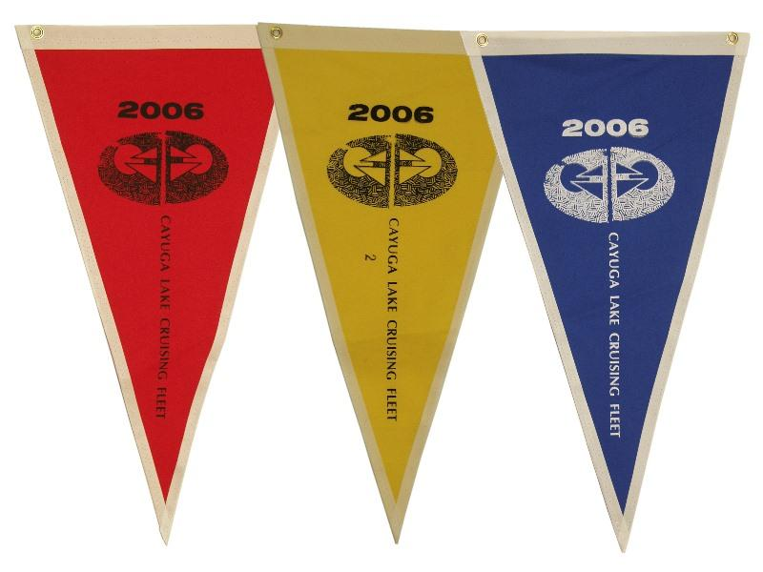
Red Jacket Regatta
Cayuga Lake Cruising Fleet
Invites
All Sailboats
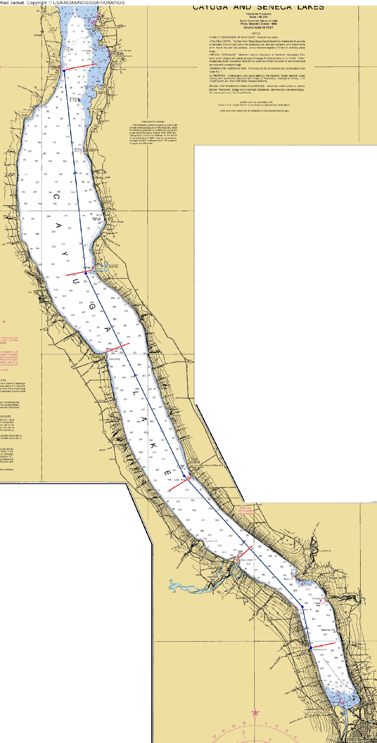
To join us in an endurance race on Cayuga Lake

Saturday, August 24th.
Skipper’s Meeting 7:30AM
At the South Pavilion of the Ithaca Yacht Club
Bermuda-style Start 8AM

The race is open to any sailboat. There is no fee to enter. You do not need to be a Cruising Fleet or Yacht Club member. Don’t worry if you do not know your boat’s rating. We will figure out your handicap.

The race will be followed by awards, a meal, lawn games and casino night at the Red Jacket Yacht Club! Meal reservations separate and required by August 18!

For more information, contact
Rick Bray
CayugaLakeCruisingFleet@gmail.com

https://www.facebook.com/groups/CayugaLakeCF
http://www.cruisingfleet.org
Ithaca Yacht Club
Red Jacket Regatta 2019
SAILING INSTRUCTIONS

RULES
The regatta will be governed by the rules as defined in the current Racing Rules of Sailing.

ENTRIES
Any sailboat is eligible to enter.
There is no fee to enter the race. Dinner tickets must be reserved and purchased separately – before August 18.
Competitors are strongly encouraged to register for the race as early as possible. The Race Committee will provide preliminary individual start times, via email, for the race the evening of August 23.
For keelboats, The CLCF’s time-on-time PHRF ratings will be used. Boats without a PHRF certificate or rating are welcome. The race committee will try to find a rating for you at the competitors meeting. For dinghies and multihulls, US Sailing Portsmouth Yardstick ratings will be used. If the race committee is not able to assign a rating to a boat, she can still race in the “demonstration” class.

COMPETITOR’S MEETING
An optional competitors’ meeting will be held at 7:30am, at the IYC South Pavilion. At that meeting, competitors will be given their individual starting times based on their boats' handicap ratings. All competitors should have a VHF radio and listen on channel 80 for any modifications to instructions provided at the competitor’s meeting.

THE START
The start will be at 8:00am, unless postponed (see below). We will use a “Bermuda start” such that slower boats will begin at 8:00 am and faster boats will start at later intervals depending on their PHRF ratings.
The start line is from the Ithaca Yacht Club flagpole to IYC Mark A, and from Mark A on a bearing of 90°(M) all the way across the lake. Boats registered in the CLCF ‘A’ fleet, and the multihull/Portsmouth fleet, must start west of Mark A. Other boats may start anywhere on the start line.
There will be no signal at the 8:00 Am start. Boats are asked to start themselves at their appointed time according to GPS time.

POSTPONEMENT / SHORTEN COURSE
If a postponement is necessary, the race committee will make an announcement on VHF, at least 10 minutes before the start. The race committee may announce an alternative start line, and a later time for the start. The start line may be one of the following:
Taughannock: Fl R Light at marina entrance bears 240°(M)
Milliken: Pile cluster bears 070°(M)
Sheldrake: Fl R “142” light bears 260°(M)
Long Point: FL “143” pile cluster bears 090°(M)
Each start line is approximately at right angles to the course up the lake (see attached map).
With VHF announcement, the race committee may abandon the race after the start, and restart it at a later time from a more northerly start line. In the event of a restart, a regular starting sequence will be used, rather than a Bermuda start. A 5 minute start sequence will be announced by the race committee using VHF channel 80. Competitors will keep track of their finish times.
There may be some boats racing that do not have a motor. In the event of a postponement, larger boats may be requested to tow the engineless boats up to the next start line.

COURSE
The course will be from the Start to the Finish at Red Jacket Yacht Club.
During the race, each boat shall record the time they pass Long Point (Fl “143”) on a bearing of 090°(M).

CONSIDERATIONS
Shorthanded vessels are allowed to use auto-helm – be safe out there! Sail numbers do not have to match vessel numbers or even the numbers on other sails.
Any CLCF boat who chooses to take on Red Jacket Yacht Club members will be given a PHRF credit adjustment of 12 seconds per mile for each Red Jacket Yacht Club member up to and including four (4). This adjustment will affect the boat’s starting time, however, RJYC members must be present and onboard at the start in order for the boat to receive the ratings adjustment.

FINISH LINE
The finish shall be the line bearing 90°(M) from the Red Jacket Yacht Club flagpole, for a distance of 150 yards. There may optionally be an inflatable mark set approximately in front of the Red Jacket Yacht Club flagpole; if this mark is present than the finish line shall instead be between the Red Jacket Yacht Club flagpole and this mark.
Each boat shall make a note of the time they finished, and identify any boats finishing just ahead or behind them.

TIME LIMIT
Boats that finish after 5 pm will be scored as “Did not finish”.
If no boats can finish within time limit, the race committee may use Long Point as an alternative finish line. Please take note of your position and/or elapsed time at Long Point.

SCORING & TROPHIES
The Race Committee may organize the boats into a number of classes, depending on the number of entries. If a Bermuda start is used, the “Red Jacket” will be awarded to the first boat to reach the finish line. If a race postponement/shortened course occurs, the award will be given to the boat finishing with the lowest PHRF-corrected elapsed time.

2018 Red Jacket Regatta
Entry Form
Please email to CayugaLakeCruisingFleet@gmail.com

Name of Boat ………………………………………………………………………………………………………

Name of Skipper ………………………………………………………………………………………………………

Email Address ………………………………………………………………………………………………………

Phone ………………………………………………………………………………………………………

Type of boat ………………………………………………………………………………………………………

Do you carry a spinnaker? ……………

PHRF rating (if known) ……………

Will you be mooring/camping overnight at Red Jacket? ……………

Did you remember to order dinner before August 18??? ……………

