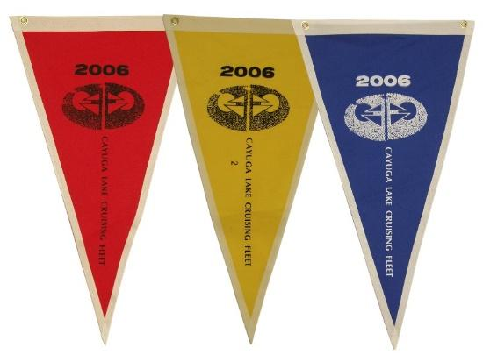
50 Mile Day Race
IYC Cayuga Lake Cruising Fleet
Invites
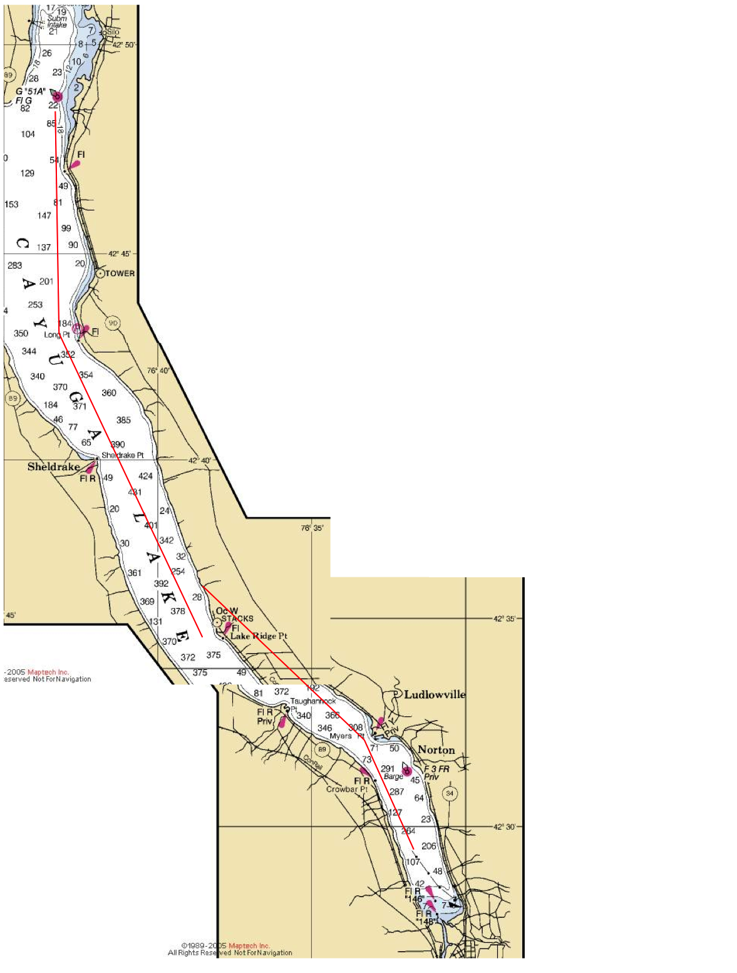
All Sailboats
To join us in an endurance race on Cayuga Lake

Saturday, September 14.
Skipper’s Meeting 7:30am
At the South Pavilion of the Ithaca Yacht Club
Start 8am

The race is open to any sailboat. There is no fee to enter. You do not need to be a Cruising Fleet or Yacht Club member. Don’t worry if you do not know your boat’s rating. We will figure out your handicap.

For more information, contact
Rick Bray
CayugaLakeCruisingFleet@gmail.com

https://www.facebook.com/groups/CayugaLakeCF
http://www.cruisingfleet.org

The IYC Cayuga Lake Cruising Fleet
50 Miler Day Race
Saturday, 14 September 2019

SAILING INSTRUCTIONS

RULES
1.1. The rules as defined in the Racing Rules of Sailing 2017-2020 with 2017-2020 US Sailing Prescriptions applied (RRS) will govern this race. The Additional Sailing Instructions for each race may further modify RRS and these Instructions.
1.2. Between the hours of sunset and sunrise, the Steering and Sailing Rules of the International Rules for the Prevention of Collisions at Sea and of the Unified Inland Rules shall replace Part 2 of RRS.
1.3. In accordance with the purpose of these races, the following equipment and practices are allowed:
a. Autopilot and/or wind-powered self-steering gear. This modifies RRS 52.
b. Twin headsails set on two poles for downwind sailing. This modifies RRS 50.2.
c. Powered winches, hydraulics, or furling devices – only on boats that have declared this information on their PHRF application and have been rated accordingly. This modifies RRS 52.

RESPONSIBILITY
It is the sole responsibility of each skipper to decide whether to start or to continue the race. Skippers are responsible for the safety of their crew. It is each boat’s responsibility to ensure all safety and nighttime equipment are used and function properly. It is HIGHLY RECOMMENED that life jackets be worn and other nighttime safety precautions are implemented from dusk ‘til dawn and as needed dependent upon weather and sea conditions.

ENTRIES
Any sailboat is eligible to enter. There is no fee to enter the race.
Enter by registering via email to CayugaLakeCruisingFleet@gmail.com or at the Ithaca Yacht Club South Pavilion before the competitors’ meeting.

SIGNALS MADE ASHORE
No Signals will be made ashore. If a postponement is needed an announcement will be made at the IYC South Pavilion, and on VHF channel 80.

COMPETITOR’S MEETING
A competitors’ meeting will be held at 7:30am at the IYC South Pavilion.

THE START
6.1. The starting line will be between Mark A (off the IYC lawn) and the Yacht Club flagpole. Boats will start in a Northerly direction.
6.2. The RC will attempt to give an accurate 5-minute warning by sound signal for the first start. This signal may also be broadcast on VHF channel 80. However, the start is determined by GPS time, not by the sound/VHF.
6.3. Competitors will record their finish times as accurately as possible, and will note the approximate position of other boats in the vicinity. They must give this information to the RC as soon as possible after the RC’s boat has docked.
6.4. GPS recordings will be used to determine actual start and finish times.

COURSE
The course will be from the Start to Mark 51A (approximate location = N 42 ̊48.843 W 76 ̊43.234) and back to the Finish. Mark 51A shall be left to port. The total distance is approximately 50 statute miles (43 ½ nautical miles).

FINISHING LINE
The finishing line will be between Mark A (off the IYC lawn) and the Ithaca Yacht Club flagpole. Boats will finish in a Southerly direction.

TIME LIMIT
There is no time limit.

SPECIAL CONSIDERATIONS
The use of automated helm or pilot is allowed in this race.

RATINGS
The CLCF’s time-on-time PHRF ratings will be used.
Boats without a PHRF certificate or rating are welcome. The race committee will try to find a rating for you.

PROTESTS
Protests shall be lodged verbally with a fleet officer at the finish, or at the IYC, within one hour after the fleet officer’s boat is moored. Hearings will be held as soon as possible after the race.

TROPHIES
A trophy will be awarded to the first boat with the lowest corrected elapsed time.

G “51A”
42 ̊48.843 N
76 ̊43.234 W

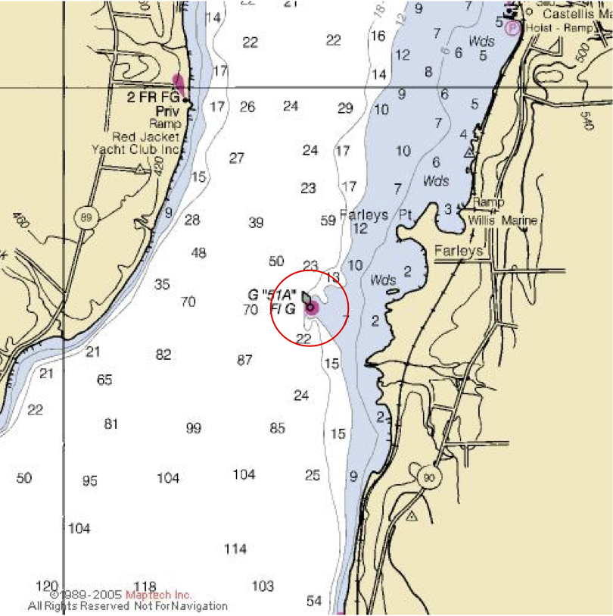

50 Miler Day Race
Entry Form
Please email to CayugaLakeCruisingFleet@gmail.com

Name of Boat ………………………………………………………………………………………………………………………..

Name of Skipper ………………………………………………………………………………………………………………………..

Email Address ………………………………………………………………………………………………………………………..

Phone ………………………………………………………………………………………………………………………..

Type of boat …………………………………………………………………………………………………………………………

Do you carry a spinnaker? …………….

PHRF rating (if known) …………….

